**ASSIGNMENT-3**

|  |  |
| --- | --- |
| **ROLL NO** | **2019503058** |
| **NAME** | **VAISHNAVANAMBI S V** |
| **Team ID** | **PNT2022TMID35667** |

**1. Create a Bucket in IBM Object Storage.**

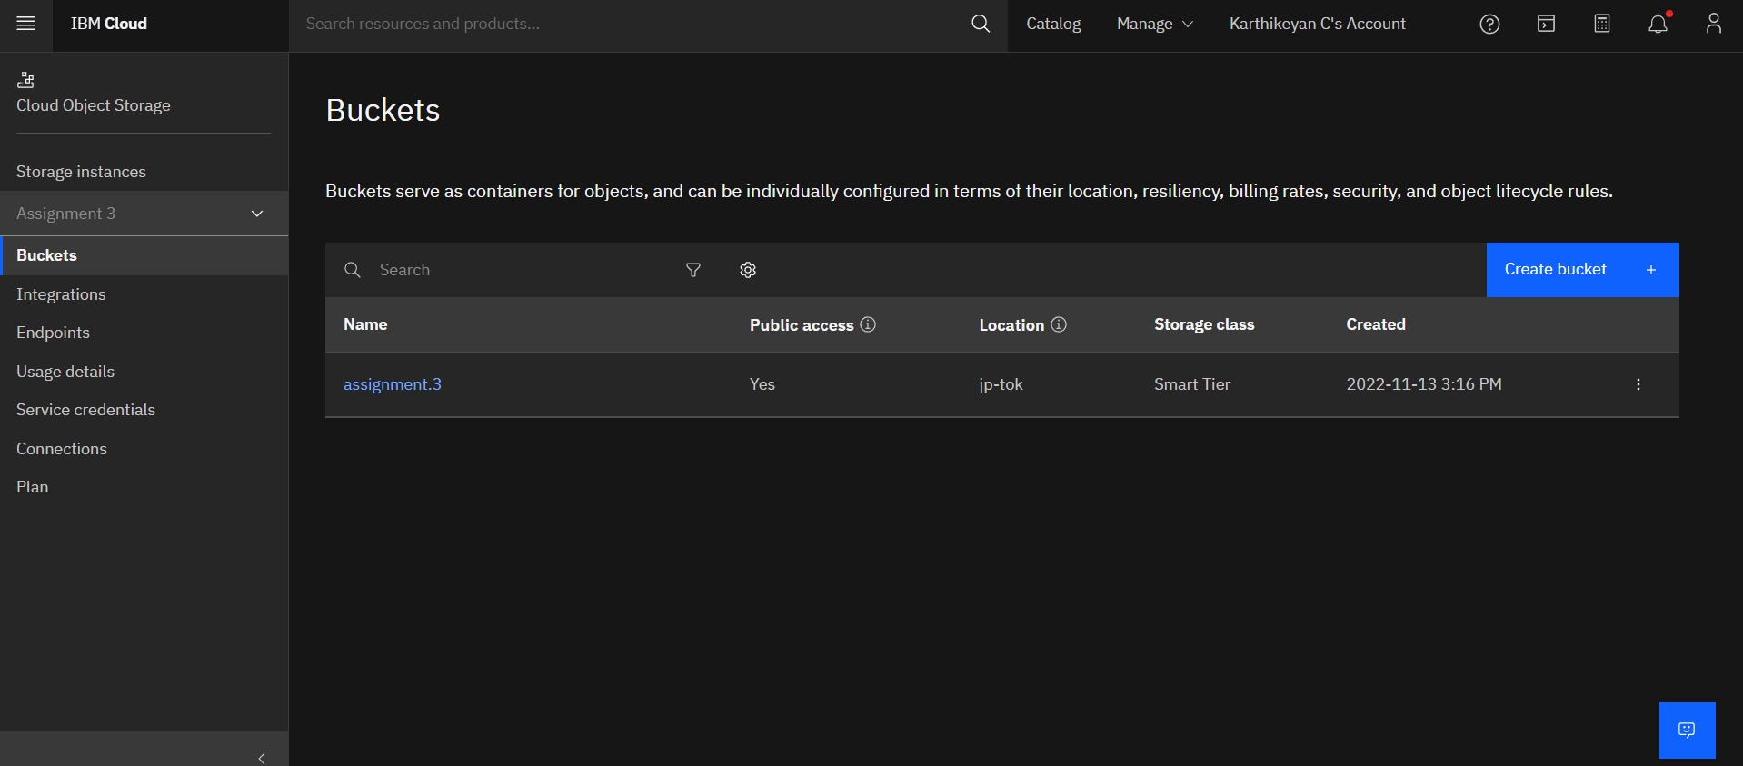

**2. Upload 5 images to IBM Object Storage Bucket and make it public. Create a HTML page and display these 5 images**.

<!DOCTYPEhtml>

<htmllang="en">

    <head>

        <metacharset="UTF-8">

        <metaname="viewport"content="width=device-width, initial-scale=1.0">

        <title>Gallery</title>

        <linkrel="stylesheet"href="https://assignment.3.s3.jp-tok.cloud-object-storage.appdomain.cloud/styles.css">

    </head>

    <body>

        <divclass="container">

            <divclass="wrapper">

                <imgsrc="https://assignment.3.s3.jp-tok.cloud-object-storage.appdomain.cloud/images/1.jfif"width="200"height="150"  alt="Image 1">

                <imgsrc="https://assignment.3.s3.jp-tok.cloud-object-storage.appdomain.cloud/images/2.jfif"width="200"height="150 alt="Image2">

                <imgsrc="https://assignment.3.s3.jp-tok.cloud-object-storage.appdomain.cloud/images/3.jfif"width="200"height="150 alt="Image3">

                <imgsrc="https://assignment.3.s3.jp-tok.cloud-object-storage.appdomain.cloud/images/4.jfif"width="200"height="150 alt="Image4">

                <imgsrc="https://assignment.3.s3.jp-tok.cloud-object-storage.appdomain.cloud/images/5.jfif"width="200"height="150 alt="Image5">

            </div>

        </div>

    </body>

</html>

OUTPUT

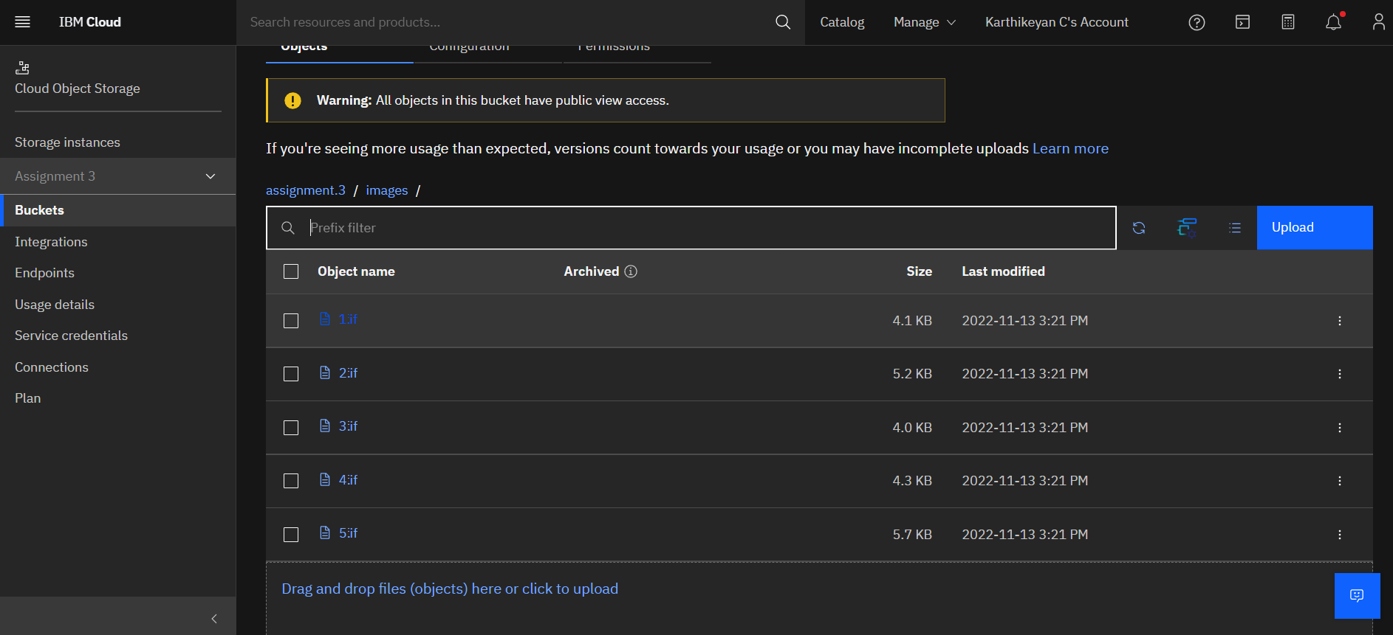

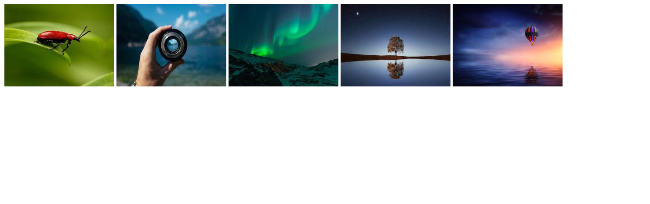

**3. Upload a CSS file to IBM Object Storage Bucket and use it on a HTML page.**

SOURCE CODE

.container{

    max-width:800px;

    margin:0auto;

}

.wrapper{

    display:flex;

    justify-content: space-between;

    width:100%;

    flex-flow: rowwrap;

}

.wrapperimg{

    margin:20px;

    flex-grow: 0;

    flex-shrink: 0;

}

OUTPUT

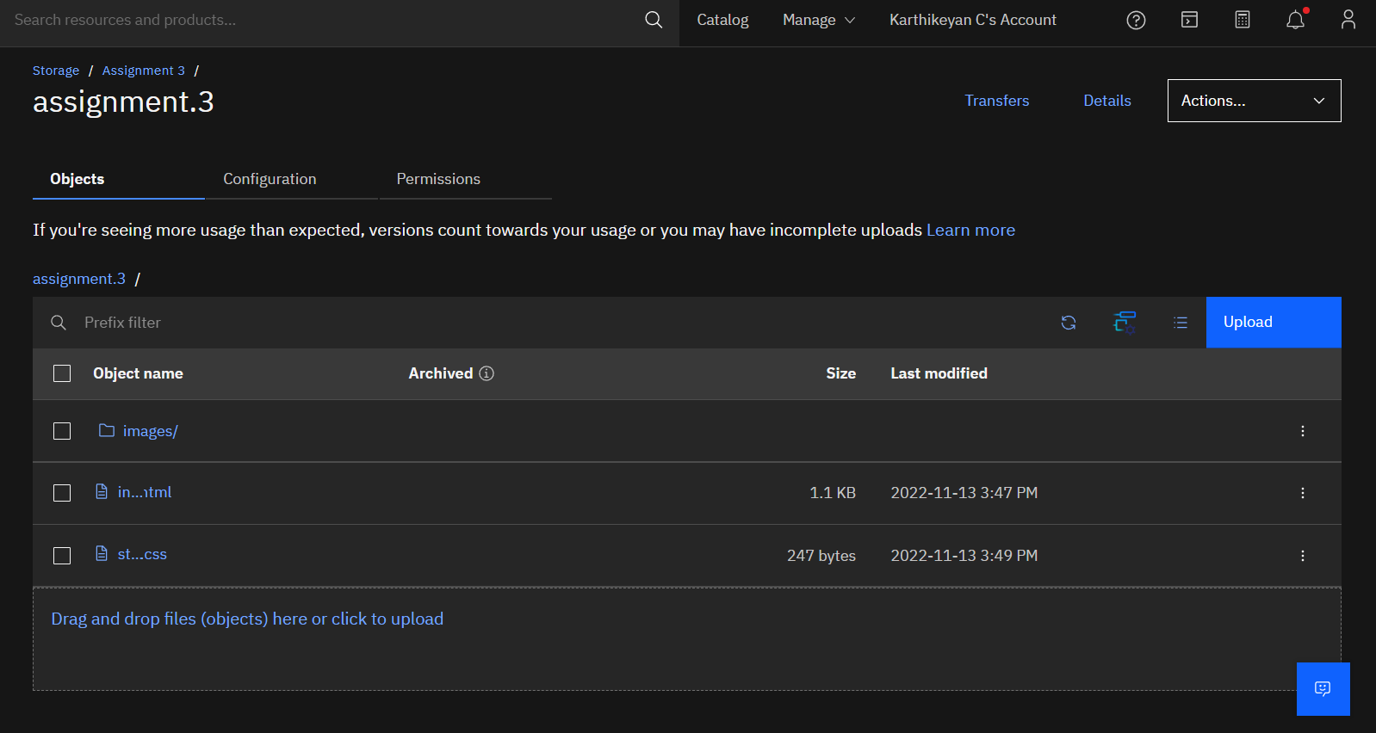

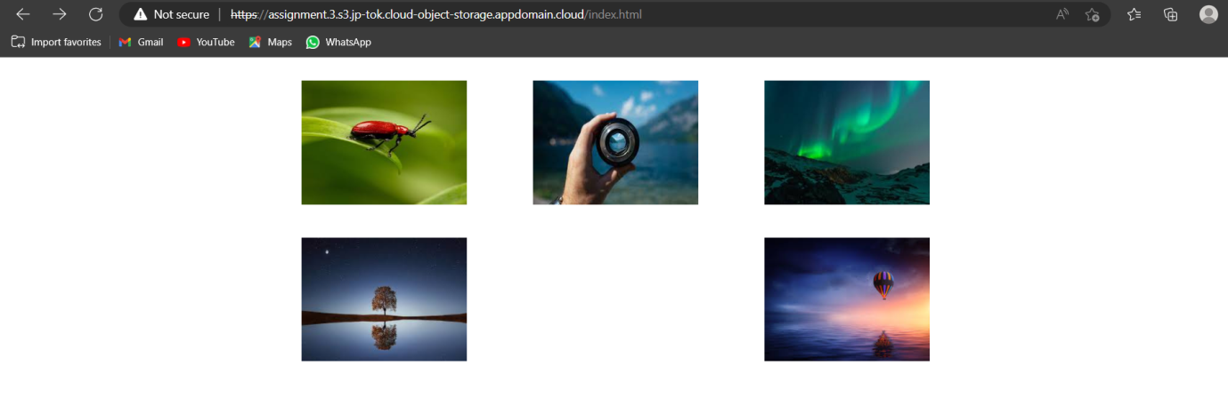

**4. Design a chat bot using IBM Watson for hospital**

<https://web-chat.global.assistant.watson.appdomain.cloud/preview.html?backgroundImageURL=https%3A%2F%2Fjp-tok.assistant.watson.cloud.ibm.com%2Fpublic%2Fimages%2Fupx-46300079-2e8a-4642-a7c0-a742c92c6e54%3A%3Ae66cc63b-36f8-4a19-b03a-60729216a268&integrationID=1242ec36-6698-43ea-b240-d893e96a3988&region=jp-tok&serviceInstanceID=46300079-2e8a-4642-a7c0-a742c92c6e54>

**5. Create a Watson assistant with 10 steps and 3 conditions and load that in HTML page**

SOURCE CODE

<!DOCTYPEhtml>

<htmllang="en">

    <head>

        <metacharset="UTF-8">

        <metahttp-equiv="X-UA-Compatible"content="IE=edge">

        <metaname="viewport"content="width=device-width, initial-scale=1.0">

        <title>Chatbot Watson</title>

    </head>

    <body>

        <script>

            window.watsonAssistantChatOptions = {

              integrationID:"1242ec36-6698-43ea-b240-d893e96a3988",

              region:"jp-tok",

              serviceInstanceID:"46300079-2e8a-4642-a7c0-a742c92c6e54",

              onLoad:function(instance) { instance.render(); }

            };

            setTimeout(function(){

              constt=document.createElement('script');

              t.src="https://web-chat.global.assistant.watson.appdomain.cloud/versions/" + (window.watsonAssistantChatOptions.clientVersion || 'latest') + "/WatsonAssistantChatEntry.js";

              document.head.appendChild(t);

            });

          </script>

    </body>

</html>

OUTPUT

